VISTA Seminar

Seminar 56

September 27, 2023

10:00 am – 11:30 am EST / 3:00 – 4:30 pm GMT London / 4:00 pm – 5:30 pm CET Paris / 10 pm CST Beijing

TOC:

1. Presenter 1: Prof. Katharine L. C. Hunt, Michigan State University, USA. page 2

2. Presenter 2: Dr. Diptarka Hait, Stanford University, USA………………...page 3

3. How to connect………………………………………………………..….. page 4

**Transition probabilities for quantum systems in time-dependent fields: Differences between Dirac’s theory and the nonadiabatic transition theory**

Katharine L. C. Hunt

*Department of Chemistry, Michigan State University*

*Currently at the Department of Physics and Materials Science, University of Luxembourg*

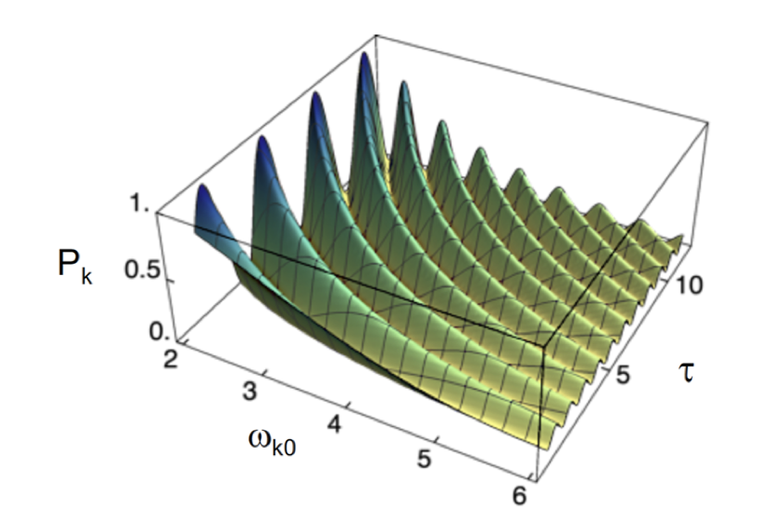 

Beginning in 1926, Dirac developed a widely-used theory of transition probabilities for quantum systems in time-dependent perturbations.1 Dirac obtained the transition probability directly by series solution of the time-dependent Schrödinger equation in terms of the eigenstates of the unperturbed Hamiltonian. Then the norm-square of each excited-state coefficient gives the probability of a transition to that state. Landau and Lifshitz2 instead separated each of Dirac’s excited state coefficients into a term that follows the adiabatic theorem of Born and Fock,3 and a term that represents excitation across an energy gap. The latter indicates the presence in the wave function of a term that is not adiabatically connected to the initial state. Extending the nonadiabatic analysis, we have shown that the energy of the system also separates completely into adiabatic and nonadiabatic terms,4 and that the power absorbed by the system from an applied field equals the time derivative of the nonadiabatic term in the energy.5 If the quantum system remains coherent, then Dirac’s approach and the nonadiabatic approach are equivalent. However, if the system is coupled to a thermal bath that can cause dephasing and population relaxation, then differences between the two approaches arise.6 Coupling to a bath was not treated by Dirac nor by Landau and Lifshitz, so it provides a “fair” test of the differences between the two approaches. We have examined the differences for model two-level systems with realistic values of T1 and T2. The differences are likely to have implications for the analysis of ultrafast molecular processes with electronic transitions.6

**References**

1) P. A. M. Dirac, *Proc. Roy. Soc. London Ser. A* **112**, 661 (1926); **114**, 243 (1927).

2) L. D. Landau and E. M. Lifshitz, in *Quantum Mechanics* (Pergamon, Oxford, 1972), Chapter 6.

3) M. Born and V. Fock, *Z. Physik* **51**, 165 (1928).

4) A. Mandal and K. L. C. Hunt, *J. Chem. Phys*. **137**, 164109 (2012).

5) A. Mandal and K. L. C. Hunt, *J. Chem. Phys*. **143**, 034102 (2015).

6) S. D. Jovanovski, A. Mandal, and K. L. C. Hunt, *J. Chem. Phys*. **158**, 164107 (2023).

**Investigating the dynamics of Jahn-Teller distortion in CH4+ with time-resolved X-ray absorption**

Diptarka Hait*a,b, ‡*

*aDepartment of Chemistry, University of California, Berkeley, CA, USA.  
bChemical Sciences Division, Lawrence Berkeley National Laboratory, Berkeley, CA, USA.  
‡Present address: Department of Chemistry and PULSE Institute, Stanford University, Stanford, CA, USA. Email:* [*diptarka@berkeley.edu*](mailto:diptarka@berkeley.edu)

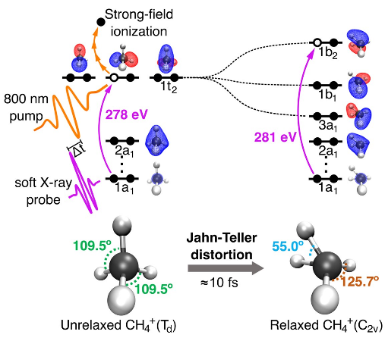 

Jahn-Teller (JT) distortions are a symmetry breaking process through which nonlinear molecules in spatially degenerate electronic states undergo nuclear displacements that lift the degeneracy by reducing molecular symmetry. JT distortions can play a crucial role in the ultrafast relaxation pathways of photoexcited or photoionized molecules. I will describe a joint experimental-theoretical time-resolved study1 of the dynamics of JT distortion in CH4+, utilizing attosecond transient absorption spectroscopy with soft X-rays at the carbon K-edge. Excellent agreement is observed between experimental spectra and theoretical X-ray absorption calculations utilizing orbital-optimized density functional theory (OO-DFT). Both theory and experiment reveal that JT distortion occurs within 10 fs after ionization, by tracing the dynamics of the signal corresponding to the excitation from the C 1s orbital to the singly occupied molecular orbital (SOMO) of CH4+. Theory further reveals that the evolution of the 1s→SOMO signal results from the dynamics of the smallest bond angle in symmetry broken CH4+. This indicates that the JT distortion activates coherent oscillations in the asymmetric scissoring vibrational mode of CH4+, which are reflected in the 1s→SOMO X-ray signal. These oscillations are damped within ~60 fs, as vibrational coherence was lost with the energy redistributing into all vibrational modes. Overall, this work elucidates the ultrafast relaxation dynamics of this prototypical system and validates the ability of OO-DFT to model and interpret experimental time-resolved X-ray absorption spectra.

**References**

1Ridente, E.*; Hait, D.*; Haugen, E.A.; Ross, A.D.; Neumark, D.M.; Head-Gordon, M.; Leone, S.R. “Femtosecond Symmetry Breaking and Coherent Relaxation of Methane Cations at the Carbon K-Edge.” *Science*. **380**, 713-717. 2023.

**How to connect**

Alexey Akimov is inviting you to a scheduled Zoom meeting.

Topic: VISTA, Seminar 56

Time: Sep 27, 2023 10:00 AM Eastern Time (US and Canada)

Join Zoom Meeting

<https://buffalo.zoom.us/j/91796116082?pwd=Zkphck83S3h3dUJQUkpPWUkzcnVIZz09>

Meeting ID: 917 9611 6082

Passcode: 082820